This video is intended to help end users learn to use the ActiveInspire software that is installed on their desktop. If you need the software installed, please click on the link below to open a ticket with our technology support services team.

<https://kipptexas.zendesk.com/hc/en-us>

1. Make sure your laptop is turned on and you are logged in.
2. Launch the ActiveInspire software by click on the shortcut on your desktop and allow it to load. Once loaded teachers normally will select the annotate over desktop option since this allows the teacher to use the board while showing lessons or web pages on the web.

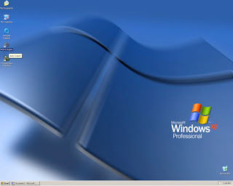

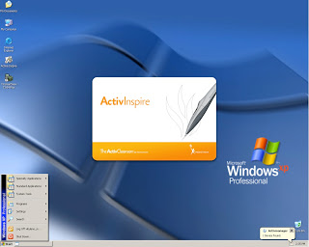

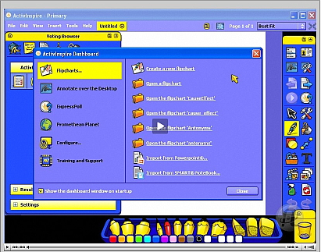

1. If you are having issues, make sure the hdmi cable is connected to and from your laptop to the board. If touch is not working, make sure the a to b printer cord is connected. Connections vary depending on the model board in your classroom. See below for what the a to b printer cord looks like:

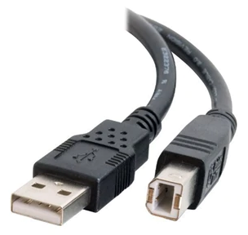

Troubleshooting Video if having issues connecting or setting up watch this video:

[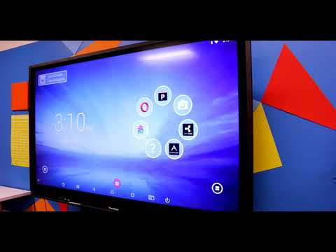](https://www.youtube.com/watch?v=j2pJ8EssbQ4)

How to use ActiveInspire Software:

[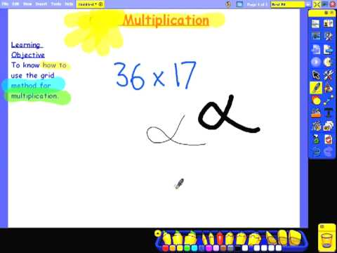](https://www.youtube.com/watch?v=EGsBwOF3kAI)

If you are still in need of assistance, please do not hesitate to reach out to your local technology department thank you.