This document is intended to help end users rotate a screen back to its default view. If the screen where to become flipped or rotated, press shift+ctrl +reload until the screen is rotated back to its original position for correct end user use.

[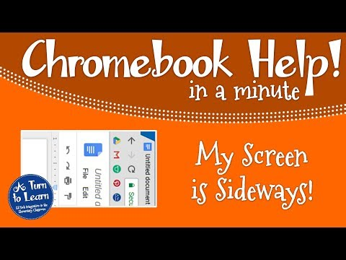](https://www.youtube.com/watch?v=pVzvMoZonWg)

Video Credits: <https://www.aturntolearn.com/chromebook-help-rotated-screen/>

If you are still having issues, do not hesitate to open a support services ticket just click on the link thank you all.

<https://kipptexas.zendesk.com/hc/en-us>