This video is intended to help our end users learn how to the use the Elmo MO-1 Document Camera. For this document camera you must use the Image Mate software. If it is not installed, please open a ticket with the link provided below. If you do have installed double click on the shortcut on your desktop titled IM & hit the power button on your doc cam. Please see the video below on how to use your document camera. If you are still having issues with your Elmo, please open a ticket via the link thank you.

Technology Support Services Link to open tickets:

<https://kipptexas.zendesk.com/hc/en-us>

[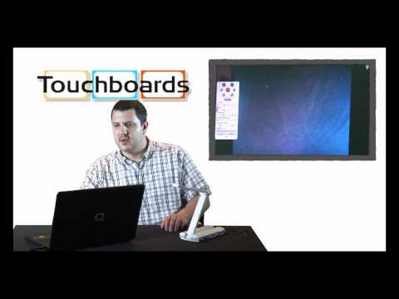](https://www.youtube.com/watch?v=Gy3tRCJXgZA)

Video Link: <https://www.youtube.com/watch?v=Gy3tRCJXgZA&feature=youtu.be>

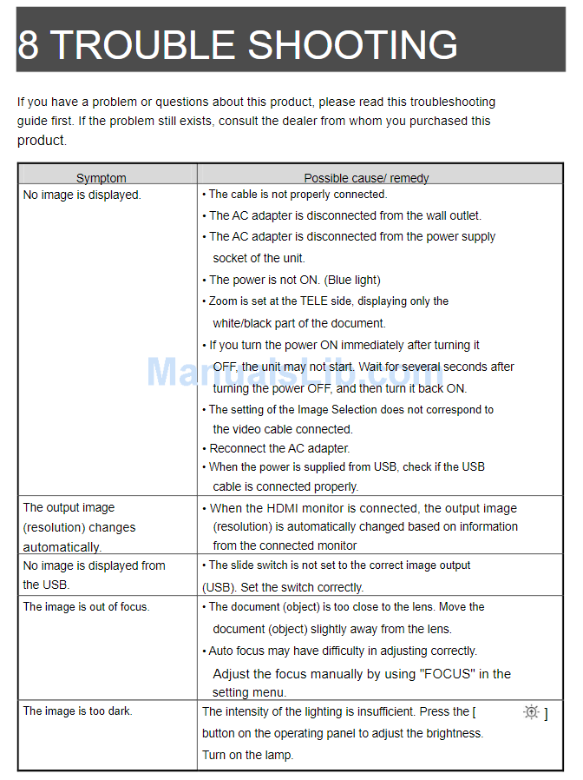

If you have tried all options, please feel free to open a service ticket with the link provided thank you.

Technology Support Services Link to open tickets:

<https://kipptexas.zendesk.com/hc/en-us>